**MOTHER TERESA WOMEN’S UNIVERSITY, KODAIKANAL SRI ADI CHUNCHANAGIRI WOMEN’S COLLEGE, CUMBUM**

**DEPARTMENT OF MATHEMATICS**

**The Tragedy of Flight: A Comprehensive crash analysis**

**1 INTRODUCTION OF PROJECT:**

An airplane crash analysis is a detailed investigation into the causes of an aviation accident. The goal of an airplane crash analysis is to identify any factors that contributed to the accident, with the ultimate goal of improving safety and preventing future accidents. The process of conducting an airplane crash analysis typically involves the collection and analysis of a wide range of data, including information about the aircraft and its systems, the operators, and any other relevant factors. This data is typically collected from Kaggle. Once the data has been collected, it is analysed through tableau, to identify any potential causes of the accident. The results of an airplane crash analysis are typically published in a report, which may include recommendations for improving safety and preventing similar accidents in the future. These recommendations may be implemented by the relevant authorities or industry organizations.

**1.1 OVERVIEW OF PROJECT:**

Name: BHARATHA VARSHINI.R

Email: rameshlatha536@gmail.com

NM_ID: 0C4C74AD7AABA9698B447A

CATEGORY: Data analytics with Tableau

PROJECT TITLE: The Tragedy of Flight: A Comprehensive crash analysis2A2E5E17F4

**TEAM MEMBERS:**

1. N. ABIRAMI
2. K. DEEPIKA
3. M.DIVYASHREE
4. S. HEMALATHA

**1.2 PURPOSE :**

Tragedy (from the Greek: τραγῳδία, tragōidia[a]) is a genre of drama based on human suffering and, mainly, the terrible or sorrowful events that befall a main character.[2] Traditionally, the intention of tragedy is to invoke an accompanying catharsis, or a "pain [that] awakens pleasure", for the audience.[ Theories of tragedy emphasize how dramatic tragedies give expression to universal human experience – pain, fear, moral confusion, loss, grief, trauma, suffering, dying, and also of the human will to struggle against fate and mortality. Such themes are central to health and medicine.

**2 PROBLEM DEFINITION AND DESIGN THINKING:**

Theories of tragedy emphasize how dramatic tragedies give expression to universal human experience – **pain, fear, moral confusion, loss, grief, trauma, suffering,** . dying, and also of the human will to struggle against fate and mortality. Such themes are central to health and medicine.

**2.1 EMPATHY MAP:** 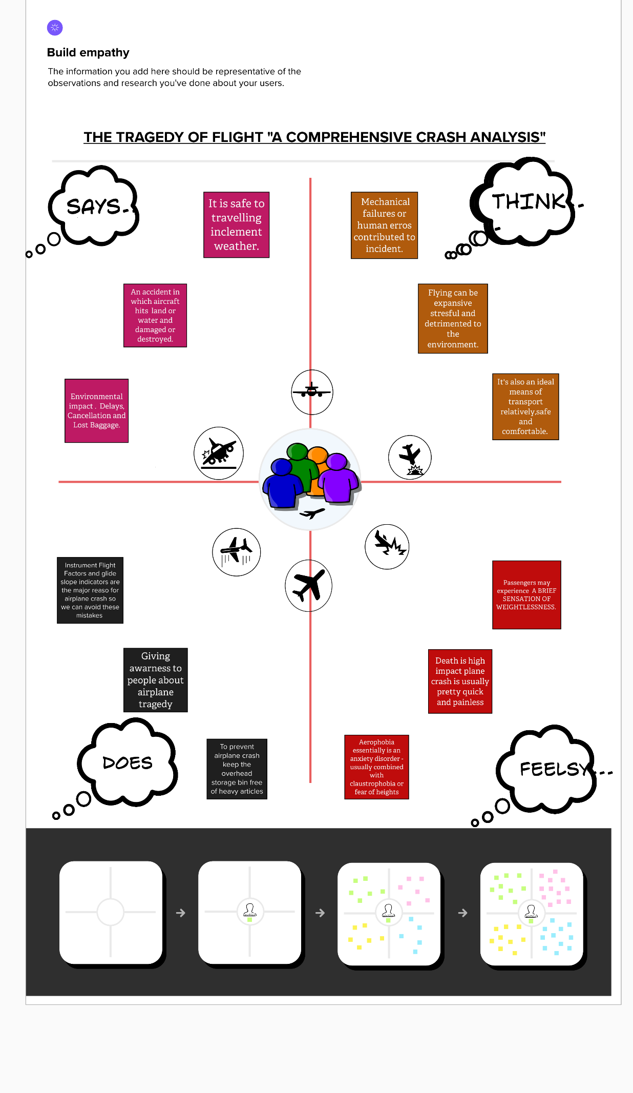

**2.2 BRAINSTROMING AND IDEA PRIORITIZE:**

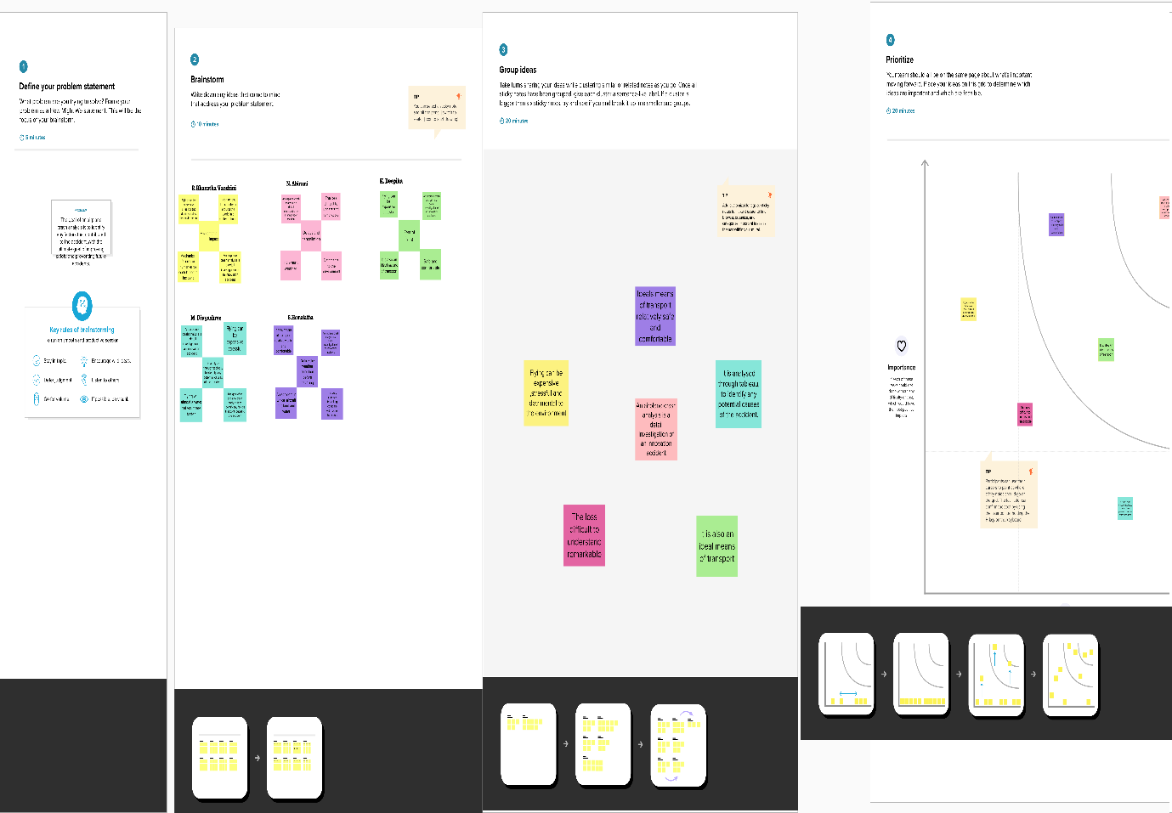

**3 RESULT FINDING (OUTPUT) OF THE PROJECT:**

**DASBOARD : 1**

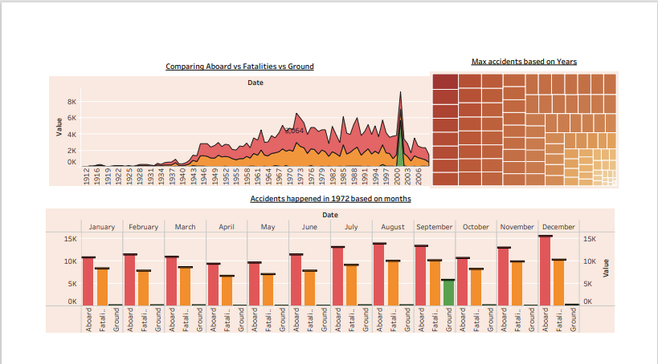

**DASBOARD : 2**

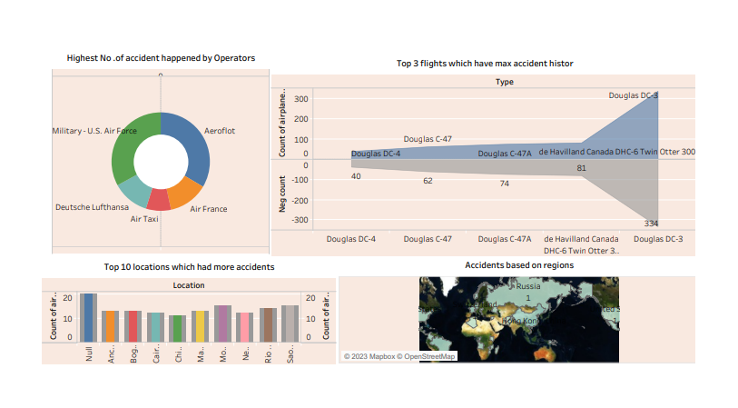

**STORY:** 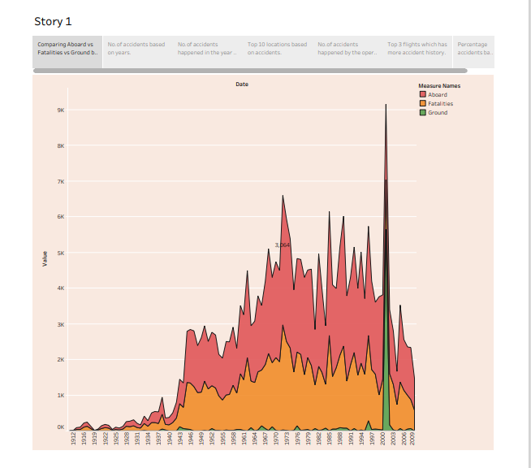

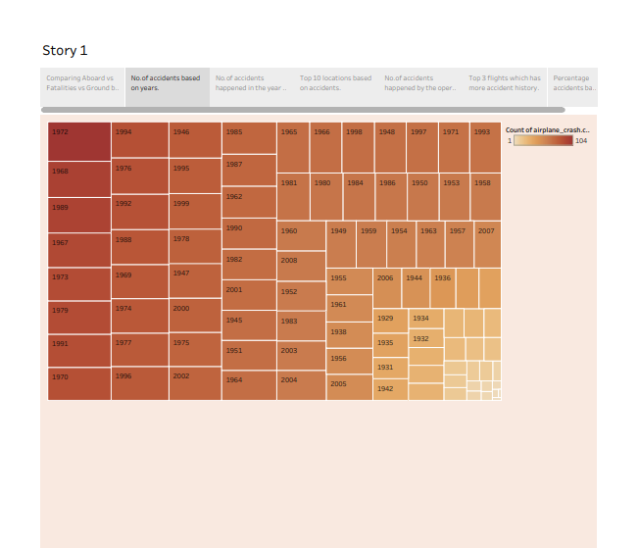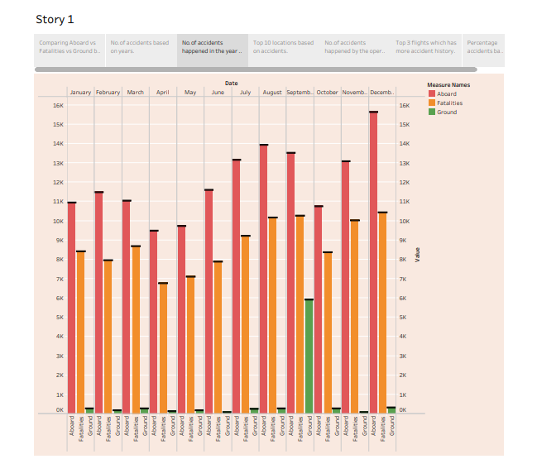

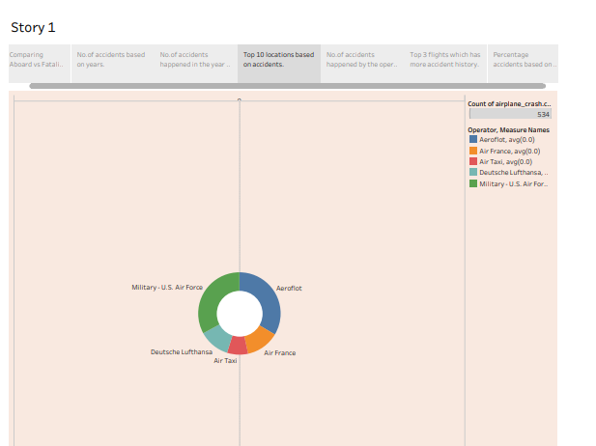

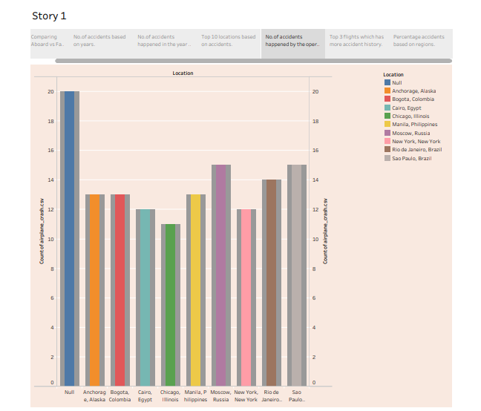

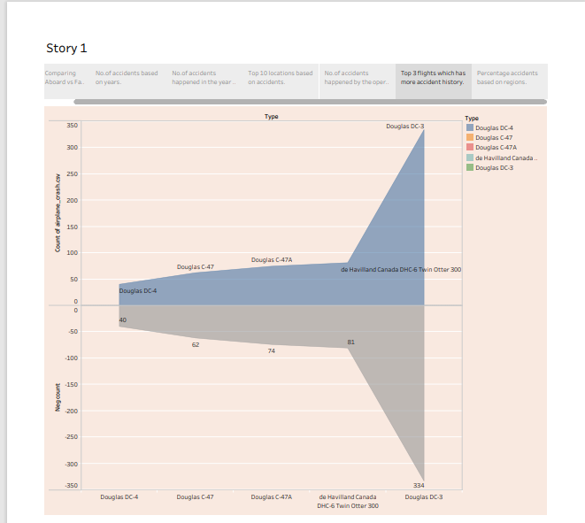

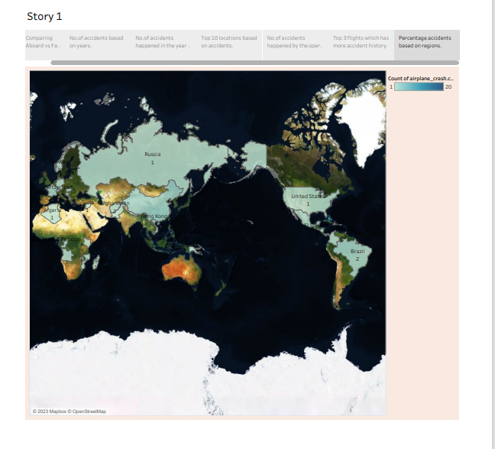

**4 ADVANTAGE AND DISADVANTAGE OF PROJECT:**

**ADVANTAGE OF TRAGEDY OF FLIGHT** :

On the one hand, air travel is the quickest way to get from A to B. It's also an ideal means of transport that is relatively safe and comfortable, thanks to advances in technology. On the other hand, flying can be expensive, stressful and detrimental to the environment. Air transport is one of the fastest modes of travel. Aeroplanes can carry people, mail and lightweight goods to distant places in the shortest time possible. They also prove to be extremely useful during the times of natural calamities, wars and other emergencies.

**DISADVANTAGE OF TRAGEDY OF FLIGHT :**

Air Transport carries certain disadvantages too and they are: (i) Cost of operating airlines is very high and so freight cost is very high as compared to sea transport. (ii) It is difficult to carry bulky, awkwardly shaped goods. (iii) Very risky in case of accident. Emissions from aviation are a significant contributor to climate change. Airplanes burn fossil fuel which not only releases CO2 emissions but also has strong warming non-CO2 effects due to nitrogen oxides (NOx), vapour trails and cloud formation triggered by the altitude at which aircraft operate.

**5 APPLICATIONS OF TRAGEDY OF FLIGHT IN AREA CAN APPLICABLE :**

The applications of Aeroplanes Image result for applications of tragedy of flights in area. The broad spectrum of uses for airplanes includes recreation, transportation of goods and people, military, and research. The military’s satellite-based Global Positioning System for civilian use.

**6 CONCLUSION:**

The constant maintenance and repair of aircraft may seem like a trivial job but they can prove to be fatal if not done properly.

• where missing screw can jeoParadise the whole aircraft .

• To prevent airplane crash keep the overhead storage Bin free of heavy articles .

• By giving Awareness two people about tragedy of airplane

**7 FUTURE SCOPE:**

After completing a cabin crew and hospitality management certification course, graduates can pursue a career as cabin crew members, ground staff, customer service executives, or airport managers. With experience and further training, they can also move on to higher roles such as airline supervisors, in-flight service managers, & airport operations managers.there are a few different sectors of aviation, with three being the main pillars that uphold the aviation industry as a whole: commercial, general, and military aviation.